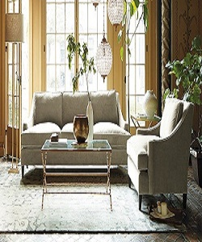

Living room Set

$143.79

Availability: In stock

Description

Grey Luxury and Soft sectional Sofa with additional wood legs to ensure stability and support. The comfortable cushioning of the headboard gives your body all the support needed to sit and relax. Available in multiple colors and sizes.